**OPERATIONAL NEED**

Rosemarie D.R. San Joaquin, the owner, only has her residence as an organizational location because she mainly owns her business. She does all the catering services and work hours with her helpers in her residence. All the processes of making the products, packing, and delivering them happen in the address, Zone 7, Mamomoton St., Vilmar Homes, Calauag 4400, Naga City, Philippines. She does not own any branches or any buildings for her business.

Upon conducting an online interview with the owner’s close friend, who happens to know the nature of the catering services and one of the group members of the team, Mr. Dante Baldonado, we, as the developers, have reviewed and analyzed the way of how they processed their sales in the said Catering Service. They are using Manual Data Processing which they write in their record book and the following are the things that they list.

* Sales
* Which includes the total amount of orders and other lists of order menus of the catering service.
* Expenses
* Total amount of the money spent, or costs incurred.
* Cash and Coins
* The total amount of income.

Rosemarie D.R. San Joaquin uses manual processing for all her transactions and business functions. Ms. San Joaquin lists down the list of orders, its amount, the total expenses, and the income she gains manually in a Record Book. This is also how she records, organizes, and fulfills the customer’s order requests. All the planning, creating, and delivering of products are also written down and managed manually.

We, as the developers, want to develop a system to speed up the transactions of the inventory and point of sale of Athena Perb’s Catering Services and to improve their time management. By creating a software-based system that allows the owner and the employee to monitor and view the records of the business’ data. In addition, it would not be time consuming since there are only a few employees in Athena Perb’s Catering Services.

**THE NEEDS DOCUMENT**

**OF**

**ATHENA PERB’S CATERING SERVICES: A POS AND INVENTORY**

**SOFTWARE-BASED SYSTEM**

Baldonado, Dante D.

Dia, Maria Feliza F.

Otic, Jogie A.

Pano, Rose Bianca Frances V.

1. **INTRODUCTION**

**Background of the study**

Athena Perb’s Catering Services are having a hard time to compute their sales and to show their menu to the customer. Just like what Mr. Baldonado has experienced, he was instructed by the owner to write all the records of the sales and transactions related to the catering services, the difficulties that he encountered was the repeated computation of sales and due to that, the total amount of sales is not accurate from the previous computation. In addition, to get the exact amount, Mr. Baldonado needs to double check the previous total sales and compare it to the current total sales which is very time consuming for the said business.

This project aims to address the needs of the owner and employee by creating a software-based system in which the owner and employees of Athena Perb’s Catering Services can login an account, one for the owner, one for the employee, these two subjects have its different interfaces but its data and information are all interconnected. Both of the interfaces can view their point of sales and inventory offline. The process of computation in this system is somehow similar to other software like Microsoft Excel and Google Sheets. Since Athena Perb’s Catering Services has an assigned employee or also known as the Sales Manager, they are authorized to access their point of sale and inventory in the system, so they don’t need to share their data unlike google sheets. This project also aims to fasten the process of computing the total sales, editing and viewing all the records of Athena Perb’s by using the formula that the owner will be providing to the developers.

1. **MISSION STATEMENT**

The mission of this project is to provide the following:

1. A software-based system that allows the **OWNER** to display the food they serve, edit and view the sales and inventory of the system.
   1. A software-based technology that allows the owner to login to an account which can access through the point of sales, edit, and view the inventory of the system.
2. A software-based system that allows the **EMPLOYEE** to monitor the records of their data in the system and edit features in the system, specifically the customer’s orders.
3. A software-based technology that allows the employee to login their accounts that were given by the owner and input the needs information of the customers, and the customer’s order.

**3. TECHNICAL OBJECTIVES**

1. A software-based system that allows the **OWNER** to display the food they serve, edit and view the sales and inventory of the system.

| **Technical Objectives** | **Performance Measures** |
| --- | --- |
| Create a software-based system that allows the owner to login an account. | Presence of a login module requires 25-30 rounds of test cases. Target goal should be a 100% success.  Owners must be able to login and logout of the system. Requires 50-60 test cases to know if it fails or if it's a success. Target goal should be a 100% success. |
| Create a software-based system that allows registered owners to create, read, update, and delete the in the “Users”. | Presence of a table to see the list of user records. Requires less than 50 series of tests. Target goal should be 100%.  Presence of an entry form module for user’s information/record. Owners must be able to create, read, delete, and update a post of stocks. Owners must be able to view a list of the user’s records. Should be at least 80-90% to achieve the success target rate. |
| Create a software-based system that has a record of the user’s account information where the owner can edit or delete. | Presence of a panel frame indicating the records of the user’s account. Requires 10-15 test cases to identify if there are errors encountered. Target goal is 100%.  Presence of an update and delete module requires 25-30 rounds of testing. Target goal should be 100% success. |
| Create a software-based system that has a default view of the “Dashboard” everytime the owner logs in. | Presence of panel frame with the monthly sales invoice, Total expenses per Month, and the total customers per Month. 15-20 rounds of test cases and 100% target goal.  Presence of a panel frames of the top 5 best sellers of Athena Perb’s based on the tray count of product menu sold. 15-20 rounds of test cases and 100% target goal. |
| Create a software-based system that allows the owner to view a pop up dialog box displaying a message with a warning that the voucher has already been used. | Presence of a pop up dialog box to confirm such action. If not clicked, means that the voucher has already been recorded in the system, otherwise recorded. Requires less than a hundred test cases and a target goal of 90-100%. |
| Create a software-based system that allows registered owners to post the food that they serve located in the “Product Menu”. | Presence of an entry form module for product menu and packages. Owners must be able to create, read, delete, and update a post of product menu and packages. Owners must be able to view a list of product menus and a list of packages they offer. Should be at least 80-90% to achieve the success target rate. |
| Create a software-based system that allows the owner to cancel or edit the orders. | Presence of a pop up dialog box to confirm such action. Requires less than a hundred test cases and a target goal of 90-100%. |
| Create a software-based system that allows the registered owners to add the customers information and their orders. | Presence of a login module requires 25-30 rounds of test cases. Target goal should be a 100% success.  Presence of a post form module. Owners must be able to edit and delete a post if there has been a mistake in recording the sales. Requires 25-30 rounds of test cases to identify errors of bugs. Should be at least 85% to achieve the success target rate.  Presence of a selection module for the customers to select their payment method, the type of service that the customers chose, list of their orders, record of the order’s scheduled date and time, the number of pax or people to be served. Requires 15-20 rounds of test cases to identify errors of bugs. The target goal for the test should be 90%. |
| Create a software-based system that allows registered owners to view the records or history records of the sold food items. | Presence of a simple and advanced database search module, filtered by date range and sort by tray and sort by total sales to easily view a specific record of a customer. Requires around 30-50 test cases. Target goal is a 90% success rate. |
| Create a software-based system that allows registered owners to view the records of vouchers that are given and the used vouchers. | Presence of a table to see the records of vouchers and used vouchers. Requires 20-25 series of tests. Target goal should be 90-100%. |
| Create a software-based system that allows registered owners to create, read, update, and delete the in the “Stocks and Food Inventory”. | Presence of a table to see the list of inventory records. Requires less than 50 series of tests. Target goal should be 100%.  Presence of an entry form module for stock entry. Owners must be able to create, read, delete, and update a post of stocks. Owners must be able to view a list of stocks and its history. Should be at least 80-90% to achieve the success target rate. |
| Create a software-based system that allows registered owners to logout of the system. | Owners must be able to logout of the system once clicked in the side navbar. Requires 50-60 test cases to know if it fails or if it's a success. Target goal should be a 100% success. |

1. A software-based system that allows the **EMPLOYEE** to monitor the records of their data in the system and edit features in the system, specifically the customer’s orders.

| **Technical Objectives** | **Performance Measures** |
| --- | --- |
| Create a software-based system that allows the employee to login an account. | Presence of a login module requires 25-30 rounds of test cases. Target goal should be a 100% success.  Employees must be able to login and logout of the system. Requires 50-60 test cases to know if it fails or if it's a success. Target goal should be a 100% success. |
| Create a software-based system that allows the employee to fill up his/her information located in the “Users”. | Presence of a post form module. Employees must be able to create, read, update and delete a post if there has been a mistake in filling up his/her records. Requires 25-30 rounds of test cases to identify errors of bugs. Should be at least 90-100% to achieve the success target rate.   Employees must be able to view a list of his/her records in a table form. Should be at least 80-90% to achieve the success target rate. |
| Create a software-based system that has a default view of the “Dashboard” every time the employee logs in. | Presence of a panel frames of the top 5 best sellers of Athena Perb’s where the employee can only view. 15-20 rounds of test cases and 100% target goal. |
| Create a software-based system that allows the employee to view a pop up dialog box displaying a message with a warning that the voucher has already been used. | Presence of a pop up dialog box to confirm such action. If not clicked, means that the voucher has already been recorded in the system, otherwise recorded. Requires less than a hundred test cases and a target goal of 90-100%. |
| Create a software-based system that allows the registered employee to add the customers information and their orders. | Presence of a login module requires 25-30 rounds of test cases. Target goal should be a 100% success.  Presence of a post form module owners must be able to edit and delete a post if there has been a mistake in recording the sales. Requires 25-30 rounds of test cases to identify errors of bugs. Should be at least 85% to achieve the success target rate.  Presence of a post form module registered employees must be able to create and view the sales and inventory. Requires 20-30 rounds of test cases to identify errors of bugs. Should be at least 80-90% to achieve the success rate.  Presence of a selection module for the employee to list down customers orders by choosing what are the customers mode of payment, the type of service that the customers chose, list of their orders, record of the order’s scheduled date and time, the number of pax or people to be served. Requires 20-30 rounds of test cases to identify errors of bugs. The target goal for the test should be 85 - 90%. |
| Create a software-based system that allows the registered employees to request access for the owner to edit in the customer's order. | Presence of a pop up dialog box to confirm such action. Requires less than 50 rounds of test cases and a target goal of 90-100%. |
| Create a software-based system that allows registered employees to logout of the system. | Employees must be able to logout of the system once clicked in the side navbar. Requires 50-60 test cases to know if it fails or if it's a success. Target goal should be a 100% success. |

**4. SCOPE AND LIMITATIONS**

The project is concerned with developing a software-based system that allows registered owners to access, update, create, and remove the variety of food products they are offering and to view the lists of order menus, list of the amount of orders they gain, the list of their total expenses and list of income. This project allows the owner to edit the food services’ information and view the point of sale and inventory of the system. This project also allows the employee to place whatever catering orders of the customers put in. This helps the business owners in their daily transactions and business processes so that they can easily keep track of their order lists and salary. This software-based system would lessen the amount of work that they have to do and would make every process easier and more efficient.

The software-based system is guaranteed to work for a mobile device but the developers will not promise to accomplish it fully with the limited amount of time given. The creators will try to cover or develop a web-based system to gain more learning on how it works by using the cloud storage and the web-based system only covers the owner's interface. Us, the developers will not cover the creation of a user due to the fact that the creation of the user is covered by the owners therefore the creators will no longer cover that part. The developers will only cover the owner and employee portion.

This project is expected to complete within 2 to 3 months because the developers want the system to be deployed before a special event in Ateneo occurs.

**CONCEPTUAL FUNCTIONAL MODEL**

**OF**

**ATHENA PERB’S CATERING SERVICES: A POS AND INVENTORY**

**SOFTWARE-BASED SYSTEM**

1. A software-based system that allows the **OWNER** to display the food they serve, edit and view the sales and inventory of the system.

**Technical Objective 1: Create a software-based system that allows the owner to login an account.**

OPERATIONAL SCENARIO:

Once the owner or employee visits the software-based system they will be presented with a login page. In the login page they will provide the email and password that was given by the developers and when they click the “Login” button the system will verify their information and if the login is successful they will be redirected to the “Dashboard” otherwise, they will be redirected back to the “Login” page with an error message.

**Technical Objective 2: Create a software-based system that allows registered owners to create, read, update, and delete the in the “Users”.**

OPERATIONAL SCENARIO:

Once the owner has logged in, the owner will be able to see the administrator profile on the top side portion where the “User” button is also located. Once the “User” button is clicked, the owner will be redirected to the “Users Page” where there will be a form where users can fill up their contact information.

**Technical Objective 3: Create a software-based system that has a record of the user’s account information where the owner can edit or delete.**

OPERATIONAL SCENARIO:

Once the owner has logged in, the owner will be able to see the administrator profile on the top side portion where the “User” button is also located. Once the “User” button is clicked, the owner will be redirected to the “Users Page” where there will be a table of the users account information and on the last part of the table there will be actions such as an icon of an edit and delete button where the owner only can change.

**Technical Objective 4: Create a software- based system that has a default view of the “Dashboard” everytime the owner logs in.**

OPERATIONAL SCENARIO:

In the “Dashboard” if the user that logged in is the owner, they can see the total monthly sales, the total expenses per month, and the number of customers per month, and also the best seller of Athena Perb’s Menu.

**Technical Objective 5 - Create a software-based system that allows the owner to view a pop up dialog box displaying a message with a warning that the voucher has already been used.**

OPERATIONAL SCENARIO:

Once the “POS” button located in the side navigation bar has been clicked, it will be redirected to the landing page called “POS Page” where the owner can view the navigation bar. In the navigation bar, it contains “[F1] NEW TRANSACTION”, “[F2] ADD VOUCHER”, “[F3] MONTHLY SALES”, “[F5] CLEAR CART”, and “[F6] CANCEL ORDER”. The landing page called “POS Page” will be blank at first. Once the owner clicks the “[F1] NEW TRANSACTION”, the owner will be redirected to the same page having the Transaction Number indicated. Once the owner clicks the “[F2] ADD VOUCHER” the owner will see a pop up dialog box that the owner should input the voucher code, if the voucher code has already inputted or already in the system, the owner cannot click the “Save” button because it’s already recorded in the system, otherwise the owner can save the changes and the customers order will be automatically discounted in the total sales. If the owner clicks “[F3] MONTHLY SALES” the owner will be redirected to the landing page called “Monthly Sales Page” where the owner can view the sales that Athena Perb’s has recorded. If the owner clicks the “[F5] CLEAR CART” it will clear the cart of the customer's order indicated on the screen. If the owner clicks “[F6] CANCEL ORDER” it will delete the whole order of the customer in the POS Page.

**Technical Objective 6: Create a software-based system that allows registered owners to post the food that they serve located in the “Product Menu”.**

OPERATIONAL SCENARIO:

When the owner clicks the “Product Menu” button they will be redirected to the “Product Menu Page”. In the Product Menu page, the owner will be able to create, read, update and delete the list of ordered menus with a fixed package. The owner also provides a voucher as a discount if the customers meet the criteria of 50 packages.

**Technical Objective 7: Create a software-based system that allows the owner to cancel or edit the orders.**

OPERATIONAL SCENARIO:

When the owner clicks the “Product Menu” button they will be redirected to the “Product Menu Page”. In the Product Menu page, there is a button where the owner can edit or cancel the orders. Once the owner clicks the plus sign icon button, the owner will be able to create, read, update and delete records of the product menu.

**Technical Objective 8: Create a software-based system that allows the registered owners to add the customers information and their orders.**

OPERATIONAL SCENARIO:

If the owner clicks the “Customers” the owner will be redirected to the landing page called the “Customers Page” and in that page there will be tables indicating the order of the customers and the customers information. In the same page there will be a plus sign icon button on the right corner where when it is clicked, there will be a pop up dialog box where the owner can edit the customer’s order or information if there’s a mistake.

**Technical Objective 9: Create a software-based system that allows registered owners to view the records or history records of the sold food items.**

OPERATIONAL SCENARIO:

If the owner clicks the “Records” the owner will be redirected to the landing page called the “Records Page” and in that page there will be a filtered by date range, sort by tray which will be the default dropdown, and the sort by total sales and below that, the owner will see display of table indicating all the records of Athena Perb’s Catering Services and its history records.

**Technical Objective 10: Create a software-based system that allows registered owners to view the records of vouchers that are given and the used vouchers.**

OPERATIONAL SCENARIO:

If the owner clicks the “Vouchers” the owner will be redirected to the landing page called the “Vouchers Page” and in that page there will be a table indicating the records of the vouchers and the used vouchers or history vouchers.

**Technical Objective 11: Create a software-based system that allows registered owners to create, read, update, and delete the in the “Stocks and Food Inventory”.**

OPERATIONAL SCENARIO:

If the owner clicks the “Stocks and Food Inventory” the owner will be redirected to the landing page called the “Stocks and Food Inventory Page” and in that page there will be a navigation bar indicating the “Inventory List” and “Stocks”. When the “Inventory List” is clicked, the owner will be redirected to a landing page called “Inventory List Page” where the owner will view the list of records in the inventory in a form of table. On the other hand, when the owner clicks the “Stocks” button, the owner will be redirected to a landing page called “Stocks Page” where there will be a navigation bar indicating the “Stocks Entry”, and the “Stocks History”. If the Stocks Entry is clicked, the owner will view a pop up dialog box containing the acquired information to be filled. If the owner clicks the “Stocks History” the owner will view a pop up dialog box containing the list of stock records or stock history.   
  
  
**Technical Objective 12: Create a software-based system that allows registered owners to logout of the system.**

OPERATIONAL SCENARIO:

In the side navigation bar once the “Logout” button is clicked by the owner, the owner will be redirected back to the Login Page.

1. A software-based system that allows the **EMPLOYEE** to monitor the records of their data in the system and edit features in the system, specifically the customer’s orders.

**Technical Objective 1:** Create a software-based system that allows the employee to login an account.

OPERATIONAL SCENARIO:

Once the employee visits the software-based system they will be presented with a login page. In the login page they will provide the email and password that was given by the developers and when they click the “Login” button the system will verify their information and if the login is successful they will be redirected to the “Dashboard” otherwise, they will be redirected back to the “Login” page with an error message.

**Technical Objective 2:** Create a software-based system that allows the employee to fill up his/her information located in the “Users”.

OPERATIONAL SCENARIO:

Once the employee has logged in, the owner will be able to see the administrator profile on the top side portion where the “User” button is also located. Once the “User” button is clicked, the employee will be redirected to the “Users Page” where there will be a form where users can fill up their contact information.

**Technical Objective 3:** Create a software-based system that has a default view of the “Dashboard” every time the employee logs in.

OPERATIONAL SCENARIO:

Once the employee clicks the “Dashboard” the employee will be redirected to the Dashboard. In the “Dashboard”, they will only see the top 5 best selling meals.

**Technical Objective 4:** Create a software-based system that allows the employee to view a pop up dialog box displaying a message with a warning that the voucher has already been used.

OPERATIONAL SCENARIO:

Once the “POS” button located in the side navigation bar has been clicked, it will be redirected to the landing page called “POS Page” where the employee can view the navigation bar. In the navigation bar, it contains “[F1] NEW TRANSACTION”, “[F2] ADD VOUCHER”, “[F3] MONTHLY SALES”, “[F5] CLEAR CART”, and “[F6] CANCEL ORDER”. The landing page called “POS Page” will be blank at first. Once the employee clicks the “[F1] NEW TRANSACTION”, the employee will be redirected to the same page having the Transaction Number indicated. Once the employee clicks the “[F2] ADD VOUCHER” the owner will see a pop up dialog box that the employee should input the voucher code, if the voucher code has already inputted or already in the system, the employee cannot click the “Save” button because it’s already recorded in the system, otherwise the employee can save the changes and the customers order will be automatically discounted in the total sales. If the employee clicks “[F3] MONTHLY SALES” the employee will be redirected to the landing page called “Monthly Sales Page” where the employee can view the sales that Athena Perb’s has recorded. If the employee clicks the “[F5] CLEAR CART” it will clear the cart of the customer's order indicated on the screen. If the employee clicks “[F6] CANCEL ORDER” it will delete the whole order of the customer in the POS Page.

**Technical Objective 5:** Create a software-based system that allows the registered employee to add the customers information and their orders.

OPERATIONAL SCENARIO:

If the employee clicks the “Customers” the employee will be redirected to the landing page called the “Customers Page” and in that page there will be tables indicating the order of the customers and the customers information. In the same page there will be a plus sign icon button on the right corner where when it is clicked, there will be a pop up dialog box where the employee can edit the customer’s order or information if there’s a mistake.

**Technical Objective 6: Create a software-based system that allows the registered employees to request access for the owner to edit in the customer's order.**

OPERATIONAL SCENARIO:

In the “Customers” indicated at the side navigation bar, when the employee clicks it, there will be a pop up dialog box, containing the Login Page of the Owner requesting for access.

**Technical Objective 7:** Create a software-based system that allows registered employees to logout of the system.

OPERATIONAL SCENARIO:

In the side navigation bar once the “Logout” button is clicked by the employee, the employee will be redirected back to the Login Page.

**System Activity Diagram**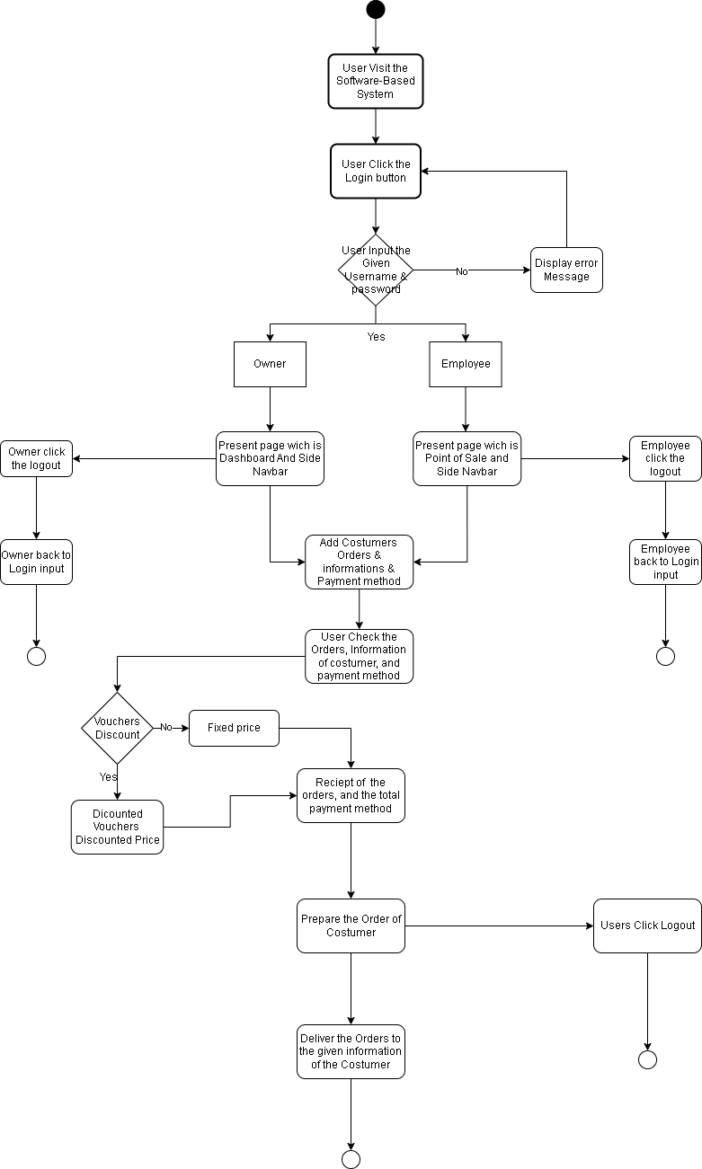

**Flowchart link:**

[**https://app.diagrams.net/#G16QeK9Y5YU185YvE9Mh4xOPBpnLPukKEr**](https://app.diagrams.net/#G16QeK9Y5YU185YvE9Mh4xOPBpnLPukKEr)

**Use Case Diagram link:** [**https://app.diagrams.net/#G1K-jOdm03g36yn92jdnh_jIHoz-rWecyM**](https://app.diagrams.net/#G1K-jOdm03g36yn92jdnh_jIHoz-rWecyM)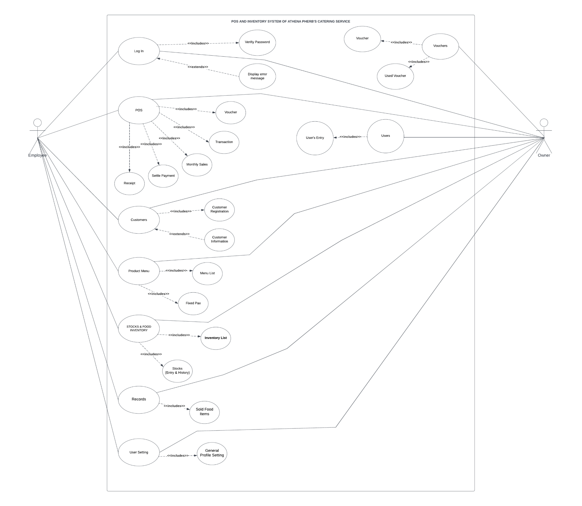

**Use-Case Diagram**

**Use-Case Diagram**

**Data Flow Diagram(DFD) link :** [**https://app.diagrams.net/#G1K-jOdm03g36yn92jdnh_jIHoz-rWecyM**](https://app.diagrams.net/#G1K-jOdm03g36yn92jdnh_jIHoz-rWecyM)

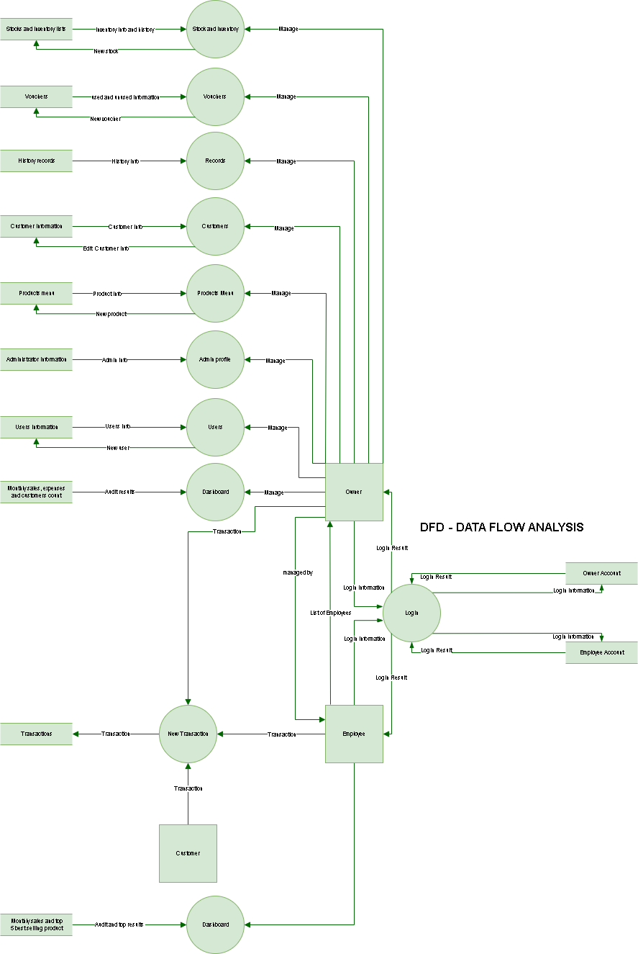

**Mock Prototype**

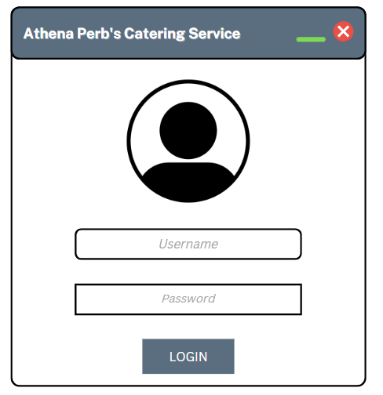

**LOGIN PAGE**

**DASHBOARD FOR THE OWNER**

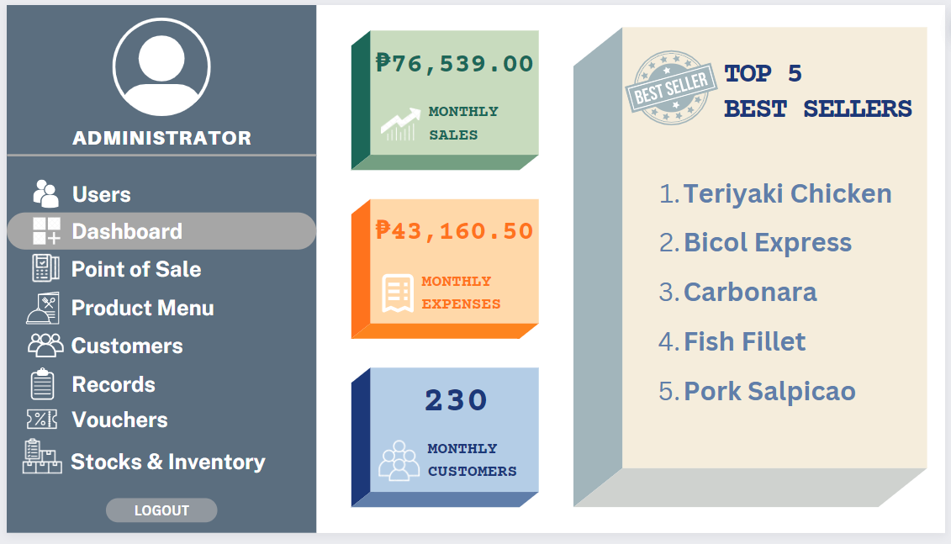

**DASHBOARD FOR THE EMPLOYEE**

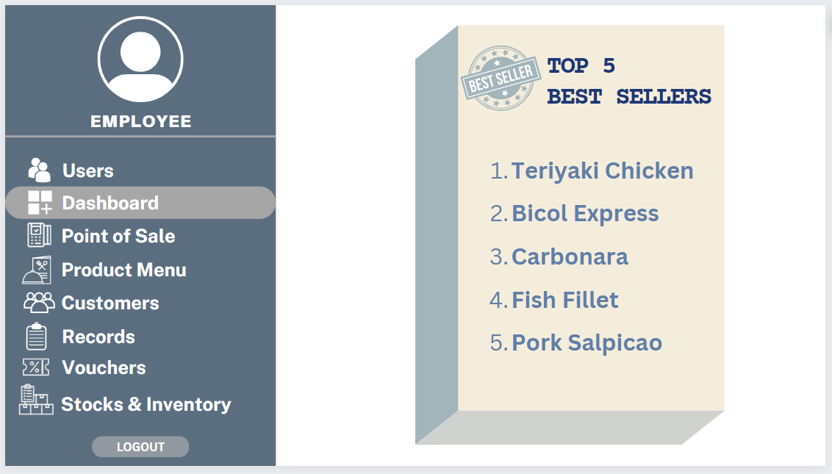

**USERS PROFILE POV OF THE OWNER**

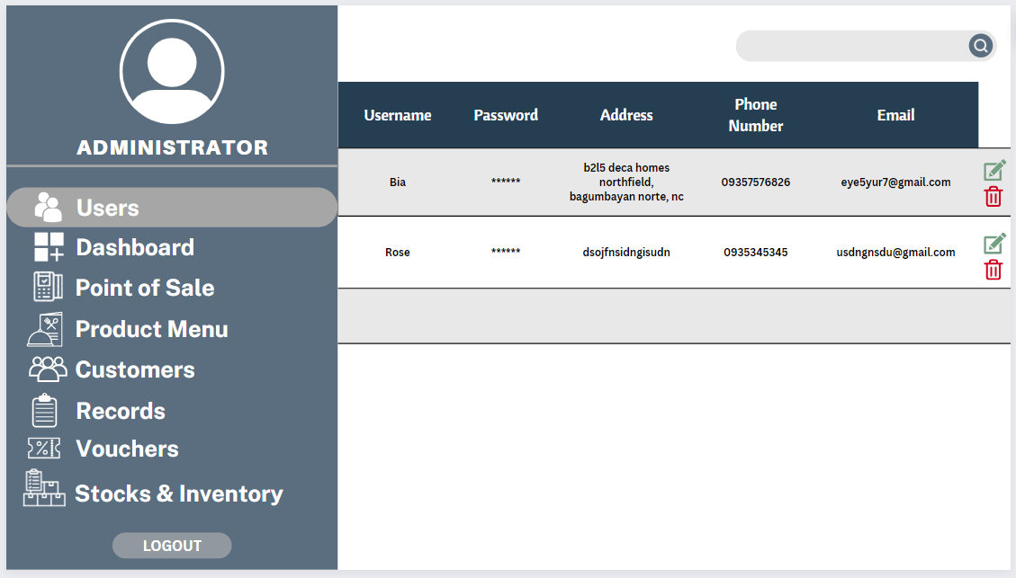

**USERS PROFILE POV OF THE EMPLOYEE**

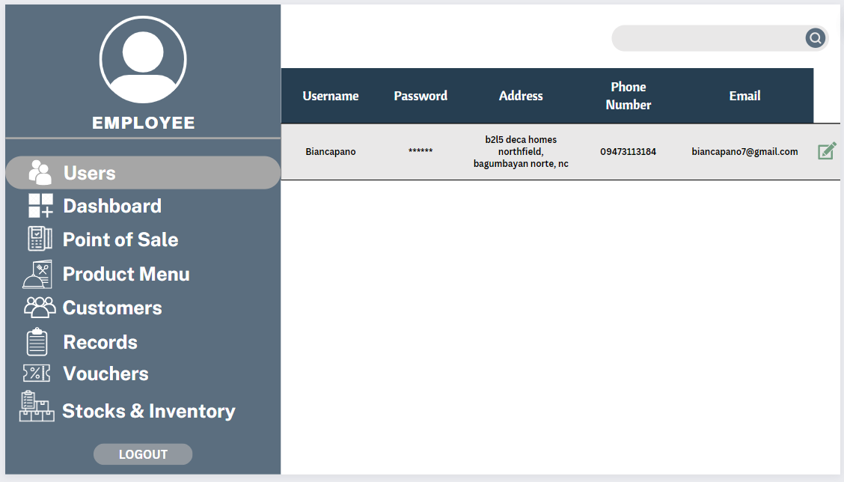

**POINT-OF-SALE POV OF THE OWNER**

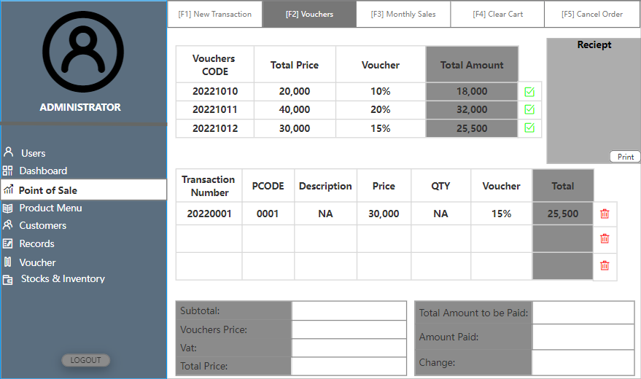

**POINT-OF-SALE POV OF THE EMPLOYEE**

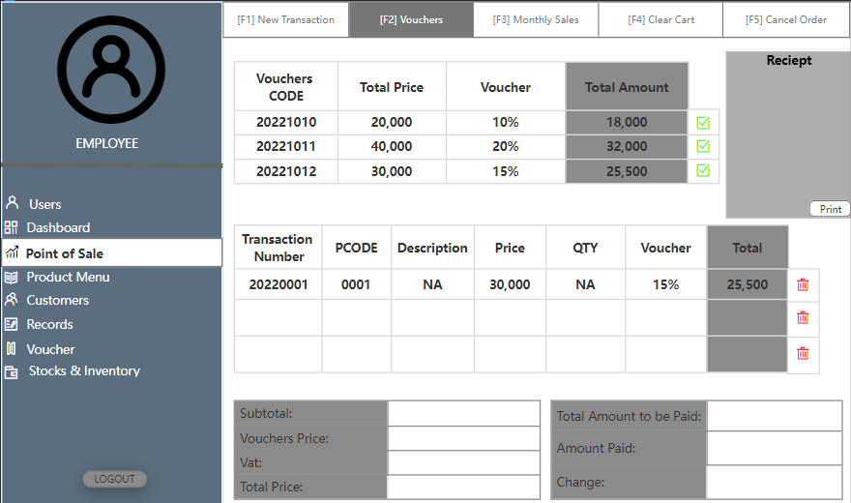

**PRODUCT MENU**

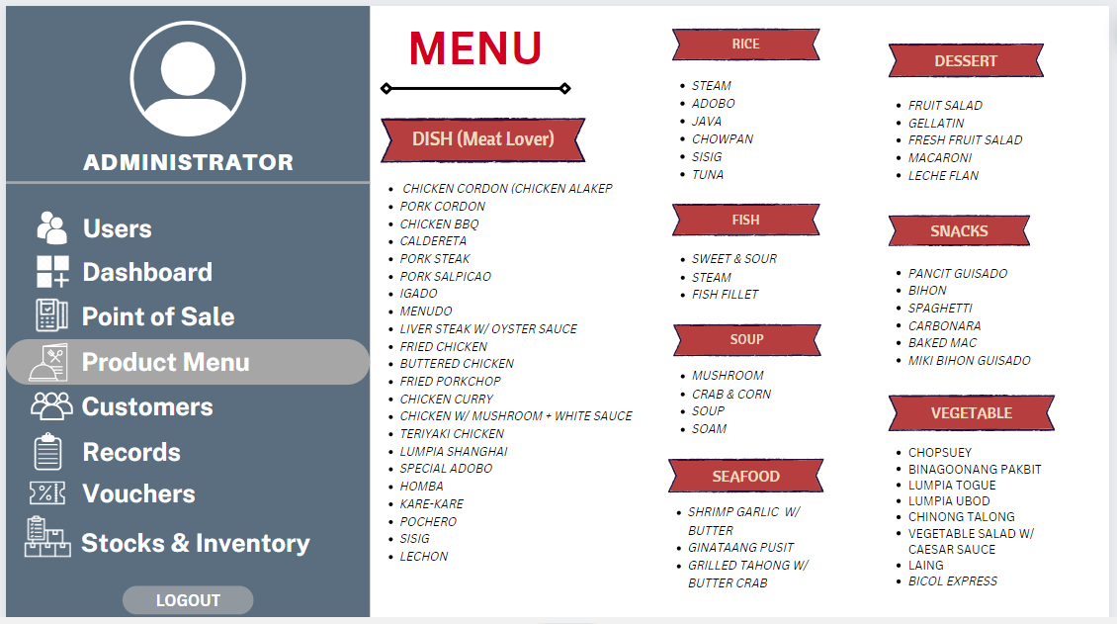

**CUSTOMERS POV OF OWNER**

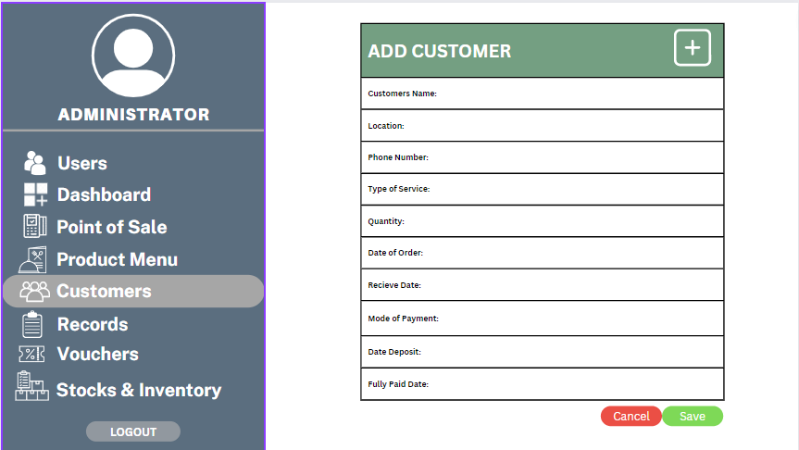

**CUSTOMERS POV OF EMPLOYEE**

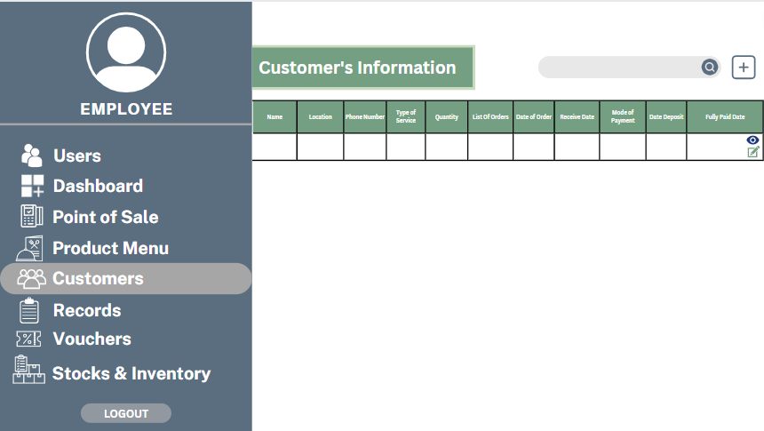

**RECORDS POV OF OWNER**

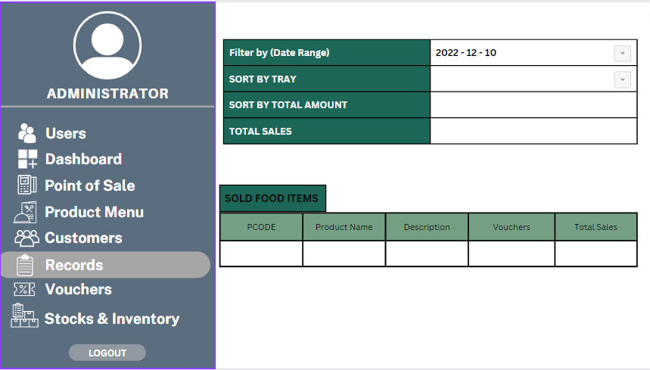

**VOUCHERS POV OF OWNER**

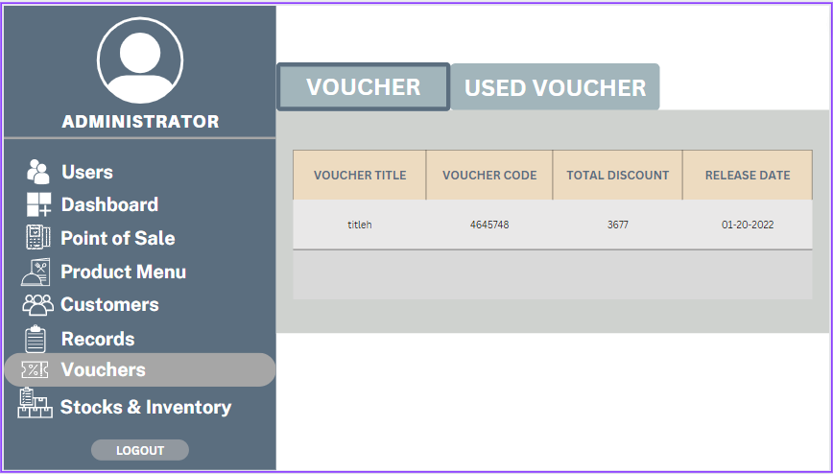

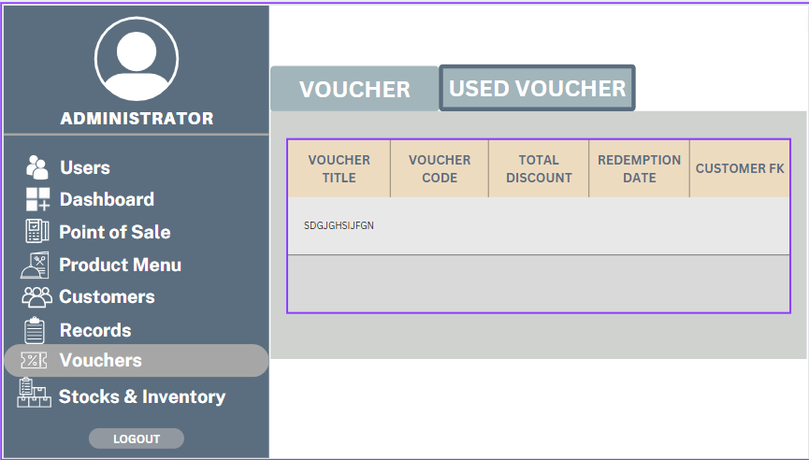

**STOCKS AND INVENTORY POV OF OWNER**

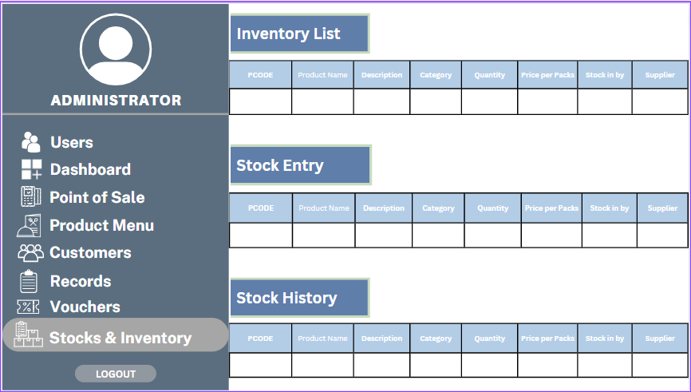

**GANTT CHART**

[**https://docs.google.com/spreadsheets/d/1X2O2oJykjImg7enwmCRABCdhJxgYtOM4p8OieaFvXBA/edit#gid=0**](https://docs.google.com/spreadsheets/d/1X2O2oJykjImg7enwmCRABCdhJxgYtOM4p8OieaFvXBA/edit#gid=0)

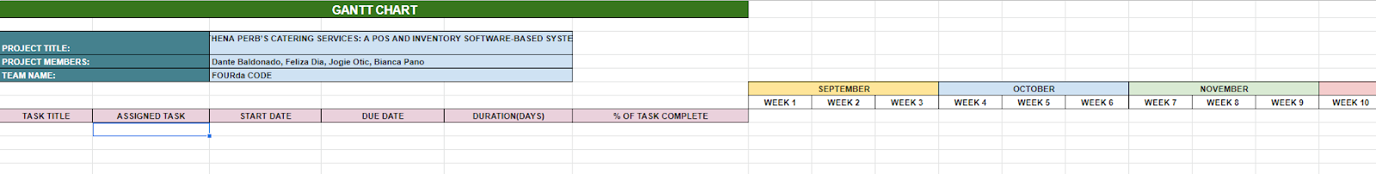

**PHYSICAL ALLOCATION**

| **NAMES** | **ROLES** |
| --- | --- |
| **DANTE BALDONADO** | * **Back-end** * **System Testing** * **Database** * **Assistance in other areas (Front-end, database etc.)** |
| **FELIZA DIA** | * **Back-end** * **Database** * **System testing** * **Assistance in other areas** |
| **JOGIE OTIC** | * **UI Design** * **Front-end** * **System Testing** * **Assistance in other areas** |
| **BIANCA PANO** | * **UI Design** * **Front-end** * **System Testing** * **Assistance in other areas** |